***Implementation of Methods and ways of calling them:***

**Default:**

**Code:**

package defaultPackage;

//calling methods

public class methods {

static int multiplyBytwo(int number) {

return number * 2;

}

public static void main(String[] args) {

int result = multiplyBytwo(2);

System.out.println("The output is: " + result);

}

}

**Output:**

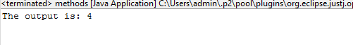

**Method Overloading:**

**Code:**

package defaultPackage;

public class Sum {

static int sum(int x, int y) {

return x + y;

}

static double sum(double x, double y) {

return x + y;

}

public static void main(String[] args) {

int int_sum = sum(10, 20);

double double_sum = sum(10.5, 23.67);

System.out.println("int: " + int_sum);

System.out.println("double: " + double_sum);

}

}

**Output:**

